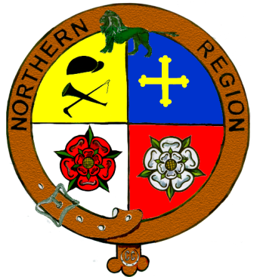

What is the Northern Region Council?
The Northern Region Council of the Caravan and Motorhome Club is built up of eleven Centres: Northumberland, Cumbria, North Lancashire, South Lancashire, Yorkshire Pennine, South Yorkshire, Durham, North Yorkshire, Yorkshire Dales, Mid West Yorkshire and East Yorkshire.
The Council holds four meetings a year with a Chairman, Treasurer, Secretary and Vice Chairman. There are two delegates from each Centre plus one non-centre member which form the committee.
What benefit is the Northern Region Council to us?
The Council has been formed to link the Centres to the Club Head Quarters. The Council feeds information from the Club to the Centres and vice versa. Any problems or concerns the Centres and their members have, can be aired at the Council meetings and if they are not solved at that meeting then the Officers of the Council can take to the Club in order to get a solution, this can then be fed back to the Centres.
The idea is a support mechanism for the Centres and their Members, as we all know that a problem shared is a problem halved or maybe solved.
Does it work?
Yes it does – many problems in the past have been solved and useful information with regard to Caravans, towing vehicles and members safety have been passed on.
Yes it does – many Centre Officers have had problems within their Centres and have brought the problem to the Council and got advice and support from other Centre Officers until a solution has been found.
Yes it does – by saving Centre Officers and member’s time by bringing things to the Council for a solution instead of contacting the Club on smaller issues or non-urgent business, this also saves the Club staff time.
Yes it does – it helps to circulate information on events the Centres run, helping to promote throughout other Centres and the Club Magazine.

